**EVALUATION**

**Random Access Patterns at Greater Speeds**

Wole Jaiyeoba, Kevin Skadron, Nima Elyasi, Changho Choi

Department of Computer Science, University of Virginia, Samsung SSI

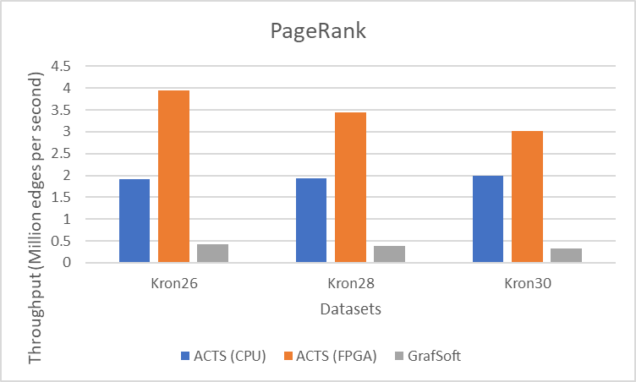

Figure 1. Performance comparisons running on PageRank algorithm

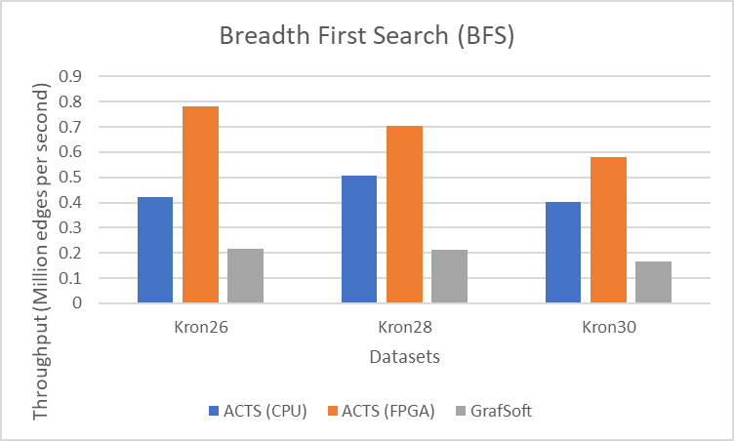

Figure 2. Performance comparisons running on BFS algorithm

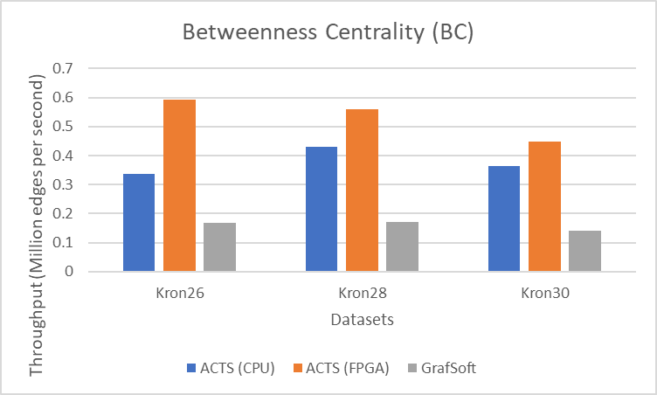

Figure 3. Performance comparisons running on BC algorithm

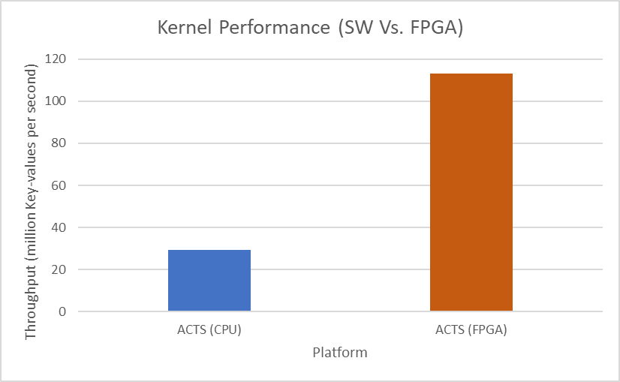

Figure 4. Comparison of kernel performance (SW Vs. FPGA)